SIMATS ENGINEERING (SAVEETHA SCHOOL OF ENGINEERING)
Department of Computer Science and Engineering
CO1 ASSESSMENT TOOL 1 – Case Study Analysis
Course Code: | CSA10 / CSA1001 | Course Title: | Software Engineering
CO Assessed: | CO1 | Assessment: | Assessment Tool 1 – Case Study Analysis
Weightage: | 20% | Total Marks: | 25
CO1 Statement: | Apply advanced methodologies and agile project management techniques to manage software projects effectively
Student Name: | Ragul R | Reg. No.: | 1911260234
Date: | 01/10/2026 | Duration: | 60 minutes

Code of Conduct
I Ragul R (1911260234)certify that this submission is my original work and that I have adhered to the guidelines specified for this assessment. I understand that any violation of academic integrity rules will result in disciplinary action.
Signature of the Student: Ragul R
Annexure A – Case Study Analysis
Instructions to Students:
Each student will be allotted one problem statement. Analyze the assigned problem systematically by following the steps given below. Your report should demonstrate your understanding of software engineering concepts and your ability to design an appropriate software solution.

Rubrics for Calculation
Criteria | Excellent (5 Marks) | Good (3 Marks) | Satisfactory (2 Marks) | Needs Improvement (1 Mark)
Problem Understanding (30%) | Clearly explains the problem, objectives, and scope with complete understanding. | Explains the problem with minor omissions. | Basic understanding with limited explanation. | Poor understanding; objectives and scope are unclear or missing.
Stakeholder & Challenge Analysis (25%) | Identifies all stakeholders, their roles, and challenges with clear analysis. | Identifies most stakeholders and challenges with adequate analysis. | Identifies only a few stakeholders or challenges. | Stakeholders and system analysis are incomplete or inaccurate.
Current System Analysis (20%) | Thoroughly analyzes the existing system, strengths, weaknesses, and identifies all gaps. | Good analysis with most strengths and weaknesses identified. | Limited analysis with partial identification of issues. | Proposed solution is unclear or inappropriate; requirements are largely missing.
Proposed Software Solution & Software Engineering Principles (15%) | Proposes an innovative, feasible solution applying appropriate software engineering principles (modularity, scalability, maintainability, security, etc.). | Suitable solution with good application of software engineering principles. | Basic solution with limited application of software engineering principles. | Methodology is inappropriate, poorly justified, or not discussed.
Methodology/ Framework Justification (10%) | Selects the most suitable SDLC/model/framework and provides strong technical justification. | Suitable methodology selected with adequate justification. | Methodology selected but justification is weak. | Outcomes, limitations, or future enhancements are missing; report lacks organization and clarity.

Criteria | Mark
Problem Understanding (30%) | /5
Stakeholder & Challenge Analysis (25%) | /5
Current System Analysis (20%) | /5
Proposed Software Solution & Software Engineering Principles (15%) | /5
Methodology/ Framework Justification (10%) | /5
TOTAL | /25

Smart College Complaint and Grievance Management System.

1. Understand the Problem Statement
1.1 Problem Statement
- In a college, students may face problems related to classrooms, transport, examinations, fees, facilities, or other services.
- Sometimes students may not know the correct person or department to approach for a particular problem.
- Complaints given verbally, through messages, or through different channels may not be properly recorded or tracked.
- After submitting a complaint, students may not know whether any action has been taken.
- Staff members may also find it difficult to manage and follow up on many complaints at the same time.
- A centralized system can make complaint submission, tracking, and resolution more organized.
1.2 Objectives of the Proposed System
- To Provide students with an easy way to submit complaints.
- To Help students check the status of their complaints.
- To Send complaints to the appropriate department.
- To Reduce delays in handling complaints.
- To Maintain proper digital records of complaints.
- To Notify students about important status updates.
- To Help college authorities monitor unresolved complaints.
1.3 Scope of the Problem
- The system can be used by students, faculty members, department staff, and administrators.
- It can handle different types of college-related complaints.
- Students can submit and track their complaints online.
- Staff can view, assign, update, and resolve complaints.
- Administrators can monitor complaints and generate reports.
- The system can later be expanded with a mobile application and other smart features.
2. Identify Key Stakeholders and Challenges
2.1 Key Stakeholders
1. Students
2. Class Representatives
3. Faculty Members
4. Department Staff
5. Class Mentors
6. Head of the Department
7. Grievance Officer
8. Student Affairs Coordinator
9. Transport Coordinator
10. Hostel Warden
11. Examination Cell Staff
12. Accounts / Finance Staff
13. College Management
14. System Administrator
15. IT Support Staff
2.2 Roles and Responsibilities of Each Stakeholder
1. Students – Submit complaints, track status, receive updates, and provide feedback.
2. Class Representatives – Help communicate common student issues and guide students in using the system.
3. Faculty Members – Review complaints related to academic or classroom issues and take suitable action.
4. Department Staff – Handle department-related complaints and update their progress.
5. Class Mentors – Support students and help direct complaints to the appropriate authority.
6. Head of the Department – Monitor department complaints and ensure appropriate action is taken.
7. Grievance Officer – Monitor grievances, assign complaints, and follow up on pending cases.
8. Student Affairs Coordinator – Coordinate student-related concerns and support grievance resolution.
9. Transport Coordinator – Handle complaints related to college transport services.
10. Hostel Warden – Handle hostel-related complaints and coordinate necessary action.
11. Examination Cell Staff – Handle examination-related complaints and provide suitable responses.
12. Accounts / Finance Staff – Handle complaints related to fees and finance-related services.
13. College Management – Review overall grievance performance and take improvement decisions.
14. System Administrator – Manage user access, system configuration, and software maintenance.
15. IT Support Staff – Provide technical support and help resolve system-related issues.
2.3 Major Challenges and Issues
- Complaints may be lost or overlooked when they are handled manually.
- Students may not receive timely updates about their complaints.
- Complaints may be sent to the wrong department.
- Tracking pending and overdue complaints can be difficult.
- Duplicate complaints may be submitted for the same issue.
- Sensitive complaints require proper privacy and security.
- A large number of complaints can be difficult to manage manually.
- It may be difficult to identify repeated or common problems without proper records.
3. Analyze the Current Approach
3.1 Existing System / Current Process
- Students may report problems directly to faculty members or department staff.
- Some complaints may be submitted using paper forms.
- Complaints may also be communicated through email or other college communication channels.
- Staff members may manually forward complaints to the appropriate authority.
- Students may need to contact staff repeatedly to know the status of a complaint.
3.2 Strengths and Limitations
- Strengths
- Students can communicate their problems personally.
- No special software or technical knowledge is required.
- Staff can immediately respond to urgent issues.
- Limitations
- There is no single centralized complaint database.
- Complaint tracking can be difficult.
- Students may not know the current status of their complaint.
- Manual processes can cause delays.
- Complaints can be misplaced or overlooked.
- Generating reports can require additional manual work.
- It may be difficult to measure the performance of different departments.
3.3 Problems / Gaps to Be Addressed
- Lack of centralized complaint management.
- Lack of real-time status tracking.
- Lack of automatic complaint assignment.
- Limited transparency in the complaint-resolution process.
- Difficulty in monitoring pending complaints.
- Difficulty in maintaining complete complaint history.
- Lack of systematic feedback collection.
4. Propose a Suitable Solution Using Software Engineering Principles
4.1 Architecture Block Diagram
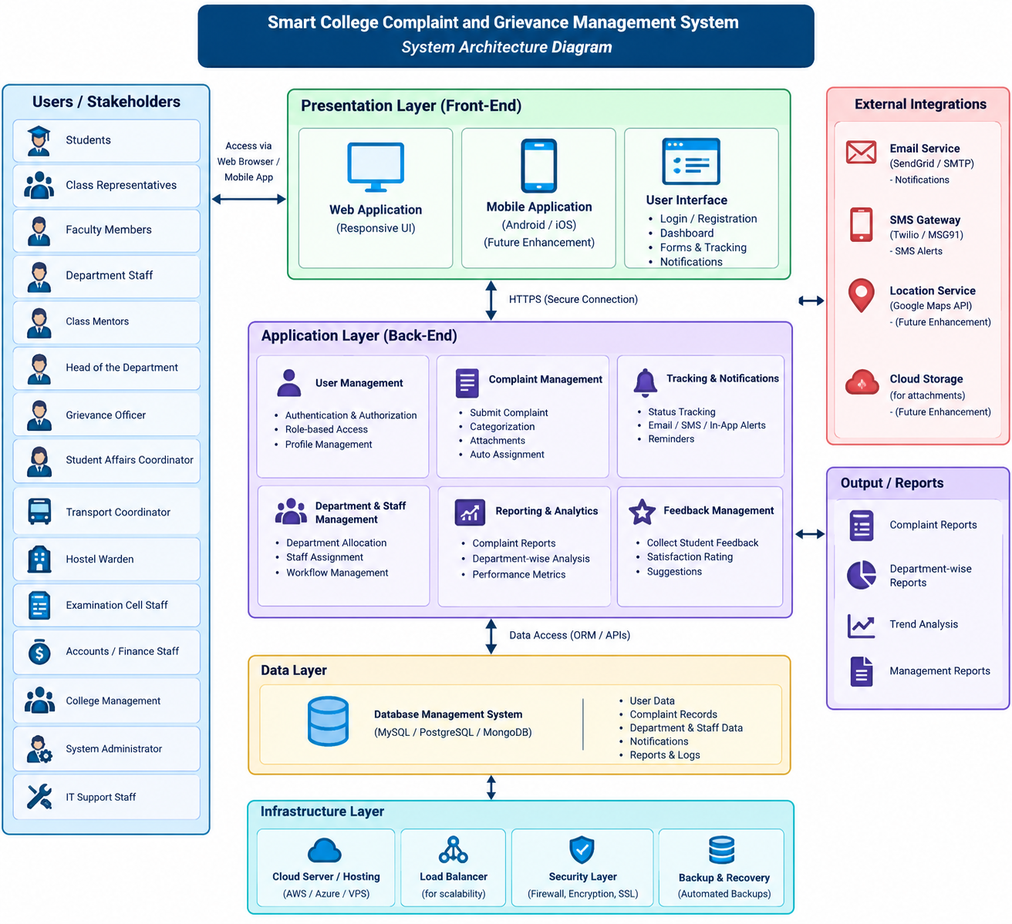
Figure 4.1: System Architecture of the Smart College Complaint and Grievance Management System
4.2 Major Functional Modules
- User Management
- Student, staff, administrator, and management accounts.
- Login and authentication.
- Role-based access.
- Complaint Submission
- Online complaint form.
- Complaint category selection.
- Description of the problem.
- Option to attach supporting documents or images.
- Complaint Assignment
- Assign complaints to the appropriate department.
- Assign complaints to responsible staff.
- Complaint Tracking
- Track complaint status.
- Display submission date and current status.
- Maintain complaint history.
- Notification Module
- Notify students when complaints are submitted.
- Notify users when complaints are assigned or updated.
- Notify students when complaints are resolved.
- Admin Dashboard
- View all complaints.
- Monitor pending and resolved complaints.
- Identify overdue complaints.
- Generate reports.
- Feedback Module
- Allow students to provide feedback after resolution.
- Record satisfaction with the resolution.
- Help management identify areas for improvement.
4.3 Functional and Non-Functional Requirements
- Functional Requirements
- User registration and login.
- Complaint submission and categorization.
- Complaint assignment to departments and staff.
- Complaint status tracking and updating.
- Notifications for important status changes.
- Feedback submission after resolution.
- Report generation and complaint monitoring.
- Non-Functional Requirements
- Usability: The system should be easy for students and staff to use.
- Security: User information and sensitive complaints should be protected.
- Reliability: The system should operate consistently.
- Performance: Complaints and status updates should be processed quickly.
- Scalability: The system should support increasing numbers of users and complaints.
- Maintainability: The software should be easy to update and maintain.
- Availability: The system should be accessible whenever users need to submit or track complaints.
4.4 Application of Software Engineering Principles
- Modularity: Divide the system into independent modules such as login, complaints, notifications, and reports.
- Scalability: Design the system so that more students, departments, and complaints can be added in the future.
- Maintainability: Use organized and well-documented code and keep system functions separated into modules.
- Reliability: Validate complaint information and maintain proper records and backups.
- Usability: Provide a simple interface with clear categories, buttons, and status indicators.
- Security: Use secure authentication, role-based access, and restricted access to sensitive information.
5. Justify the Chosen Methodology / Framework
5.1 Selected Methodology: Agile Scrum
- Requirements may change based on feedback from students and college staff.
- The system can be developed in small functional increments.
- Important modules can be developed first.
- Students and staff can provide feedback during development.
- Problems can be identified and corrected early.
- Regular testing can be performed throughout development.
5.2 Why Agile Scrum is Suitable
- It supports continuous feedback from users.
- The project can be divided into manageable sprints.
- Changes in requirements can be handled more easily.
- Working features can be delivered and tested in stages.
- Early testing helps reduce the risk of major problems at the end of development.
5.3 How It Supports Successful Project Development and Maintenance
- Sprint planning helps the team organize development tasks.
- Regular reviews help collect feedback from stakeholders.
- Continuous testing helps identify and fix defects early.
- Incremental development makes future changes easier to introduce.
- The system can be improved continuously after deployment.
5.4 Example Scrum Development
- Sprint 1 – User login and user management.
- Sprint 2 – Complaint submission and categorization.
- Sprint 3 – Complaint assignment and tracking.
- Sprint 4 – Notifications and feedback.
- Sprint 5 – Admin dashboard and reports.
- Sprint 6 – Testing, security improvements, and final deployment.
6. Discuss Expected Outcomes and Limitations
6.1 Expected Benefits
- Faster complaint submission and processing.
- Improved transparency in grievance handling.
- Students can easily track complaint status.
- Reduced manual paperwork.
- Better communication between students and departments.
- Centralized storage of complaint records.
- Easier monitoring of pending complaints.
- Improved accountability of responsible departments.
- Management can identify frequently occurring problems.
6.2 How the Solution Addresses the Challenges
- Lost complaints → Centralized digital database.
- Status uncertainty → Online complaint tracking.
- Wrong department → Categorization and proper assignment.
- Delayed action → Notifications and pending-complaint monitoring.
- Poor records → Digital complaint history.
- Lack of feedback → Built-in feedback module.
- Privacy concerns → Authentication and role-based access.
6.3 Potential Risks, Implementation Challenges, and Limitations
- Potential Risks
- Unauthorized access to sensitive complaints.
- Incorrect information entered by users.
- Technical failures or server downtime.
- Resistance from users who are accustomed to manual processes.
- Internet or network connectivity problems.
- Implementation Challenges
- Training staff and students to use the system.
- Integrating the system with existing college systems.
- Maintaining data security and privacy.
- Ensuring reliable server and network infrastructure.
- Managing different user roles and permissions.
- Limitations
- The system depends on internet or network availability.
- Users need basic digital skills.
- Emergency issues may still require direct communication.
- Incorrect information provided by users can affect complaint processing.
- Initial development and maintenance require resources.
6.4 Future Enhancements
- Mobile application for Android and iOS.
- AI-based automatic complaint categorization.
- Chatbot for basic grievance-related queries.
- Automatic detection of repeated complaints.
- Analytics to identify frequently occurring problems.
- Integration with the college student information system.
- Multilingual interface.
- SMS and email notification support.
- Priority prediction for urgent complaints.

